AWS ChatOps Solution with Terraform and GitOps

1. Overview
The AWS ChatOps Solution enables infrastructure provisioning and management through chat-based interactions. Users can request AWS resource creation, modification, or deletion directly from collaboration platforms such as Slack, Microsoft Teams, or custom web chat interfaces.
The solution leverages:
- AWS API Gateway
- AWS Lambda
- AWS Lambda Authorizer
- GitHub (GitOps Repository)
- AWS CodePipeline
- AWS CodeBuild
- Terraform
- AWS CloudWatch
- Amazon SNS
- AWS Target Resources (EC2, VPC, RDS, S3, etc.)
This architecture follows GitOps principles where all infrastructure changes are version-controlled, auditable, and automatically deployed through CI/CD pipelines.

2. Architecture Components
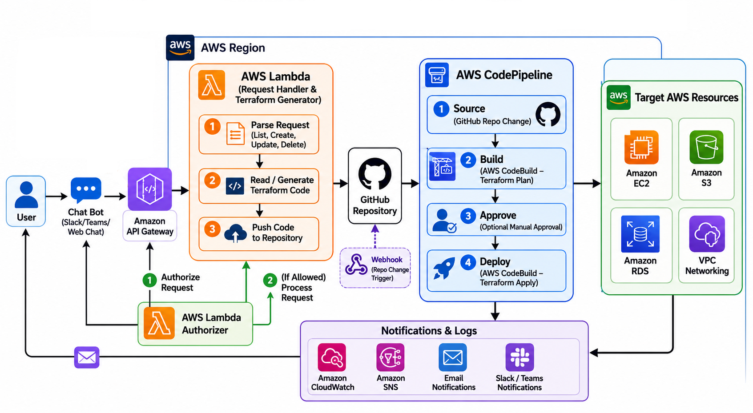

2.1 Chat Interface
Supported Platforms:
- Slack
- Microsoft Teams
- Custom Web Portal
- Internal Chat Applications
Users submit infrastructure requests using predefined commands.

Example Commands
/create ec2 instance=t3.medium env=dev

/create s3 bucket=my-app-logs

/delete ec2 instance-id=i-123456789

/list vpc


2.2 AWS API Gateway
API Gateway acts as the secure entry point for all ChatOps requests.

Responsibilities
- Receive webhook requests
- Validate request structure
- Invoke Lambda Authorizer
- Forward authorized requests to Backend Lambda

Endpoint Example
POST /chatops/request


2.3 AWS Lambda Authorizer
The Lambda Authorizer validates incoming chat requests before allowing access to backend services.

Validation Methods
- Chat Bot Token Validation
- Slack Signature Validation
- Teams Token Validation
- API Key Validation
- JWT Validation (optional)

Responsibilities
- Verify source authenticity
- Validate request signature
- Check allowed user list
- Check role permissions
- Generate IAM policy response

Authorization Flow
Chat Request
↓
API Gateway
↓
Lambda Authorizer
↓
Allow / Deny
↓
Backend Lambda

Example Authorization Policy
{
"principalId": "user123",
"policyDocument": {
"Version": "2012-10-17",
"Statement": [{
"Action": "execute-api:Invoke",
"Effect": "Allow",
"Resource": "*"
}]
}
}


2.4 AWS Lambda Request Handler
The backend Lambda processes authorized requests.

Responsibilities

Parse Request
Identify requested operation:
- Create Resource
- Update Resource
- Delete Resource
- List Resources

Generate Terraform Code
Create Terraform files dynamically:
resource "aws_instance" "web" {
ami = "ami-xxxxxxxx"
instance_type = "t3.medium"
}

Commit to GitHub
Generated code is pushed automatically to the GitOps repository.

2.5 GitHub Repository
GitHub serves as the single source of truth.

Repository Structure
terraform-gitops
│
├── environments
│ ├── dev
│ ├── qa
│ └── prod
│
├── modules
│ ├── ec2
│ ├── vpc
│ ├── rds
│ └── s3
│
└── pipelines

Benefits
- Version Control
- Change Tracking
- Rollback Capability
- Audit Compliance

2.6 AWS CodePipeline
CodePipeline automates infrastructure deployment.

Stages

Stage 1: Source
Triggered when GitHub repository changes.
GitHub Commit
↓
CodePipeline Trigger

Stage 2: Build (Terraform Plan)
AWS CodeBuild executes:
terraform init
terraform validate
terraform plan
Artifacts generated:
- Terraform Plan Output
- Validation Reports

Stage 3: Approval (Optional)
Manual approval for production environments.
Approvers:
- Cloud Team
- Platform Team
- Security Team

Stage 4: Deploy (Terraform Apply)
AWS CodeBuild executes:
terraform apply -auto-approve
Resources are deployed to AWS.

2.7 AWS Target Resources
Supported AWS Resources include:

Compute
- Amazon EC2
- Auto Scaling Groups

Storage
- Amazon S3
- Amazon EFS

Database
- Amazon RDS
- Amazon DynamoDB

Networking
- VPC
- Subnets
- Route Tables
- NAT Gateway
- Internet Gateway
- Security Groups

Security
- IAM Roles
- IAM Policies
- KMS Keys

3. Notifications and Monitoring

AWS CloudWatch
Captures:
- Lambda Logs
- API Gateway Logs
- CodeBuild Logs
- Pipeline Execution Logs

Monitoring Metrics
- Failed Deployments
- API Errors
- Authorization Failures
- Build Failures

Amazon SNS
SNS sends notifications for:

Success Events
Terraform Apply Successful

Failure Events
Terraform Plan Failed

Approval Events
Production Deployment Awaiting Approval
Notifications can be sent to:
- Email
- Slack
- Teams
- Webhooks

4. End-to-End Workflow

Resource Creation Flow

Step 1
User submits request:
/create ec2 env=dev size=t3.medium

Step 2
Chat Bot sends webhook to API Gateway.

Step 3
Lambda Authorizer validates:
- User
- Token
- Signature

Step 4
Request Handler Lambda parses command.

Step 5
Terraform code is generated.

Step 6
Terraform code is committed to GitHub.

Step 7
GitHub triggers CodePipeline.

Step 8
CodeBuild executes Terraform Plan.

Step 9
(Optional) Manual Approval.

Step 10
CodeBuild executes Terraform Apply.

Step 11
AWS resources are deployed.

Step 12
SNS notification sent to user.

5. Security Controls

Authentication
- Lambda Authorizer
- Chat Token Validation
- Signature Verification

Authorization
Role-Based Access Control (RBAC)
Example:
Developer:
Create DEV resources

Platform Team:
Create DEV/QA resources

Cloud Admin:
Full access

Audit
All actions are tracked through:
- GitHub Commit History
- CloudTrail
- CloudWatch Logs
- CodePipeline Execution Logs

6. Benefits

Infrastructure as Code
All resources managed through Terraform.

GitOps
Git repository remains the source of truth.

Self-Service Infrastructure
Users provision resources directly from chat.

Security
Lambda Authorizer ensures authenticated and authorized access.

Governance
Approval workflow prevents unauthorized production changes.

Auditability
Every change is traceable from chat command to deployment.

Lambda execution Flow:
